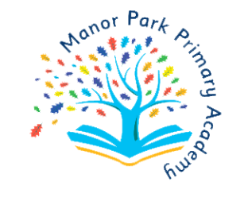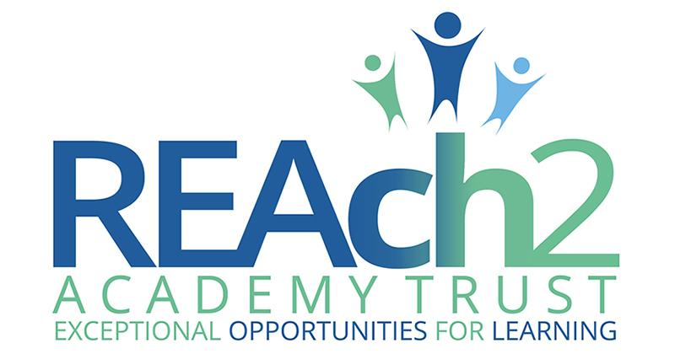 **Music Development Plan Summary:**

**Manor Park Primary Academy**

|  |  |
| --- | --- |
| Detail | Information |
| Academic year that this summary covers | 2024 - 2025 |
| Date this summary was published | June 2024 |
| Date this summary will be reviewed | June 2025 |
| Name of the school music lead | **Ruth Day** |
| Name of school leadership team member with responsibility for music (if different) | NA |
| Name of local music hub | Birmingham Services for Education – Music Service |

This is a summary of how our school delivers music education to all our pupils across three areas – curriculum music, co-curricular provision and musical experiences – and what changes we are planning in future years. This information is to help pupils and parents or carers understand what our school offers and who we work with to support our pupils’ music education.

**Curriculum Music: Part A**

At Manor Park Primary Academy we follow a curriculum which broadly echoes that of the Model Music Curriculum (March 2021) but is developed to include up to date changes in the industry, teacher specialisms and equipment.

Our curriculum includes the following:

* 60 minute weekly lessons
* Singing
* Listening
* Composing
* Performing/Instrumental Performance
* Class instrumental ensembles
* Song writing
* Improvisation
* Exposure to, and appreciation of, a range of musical genres from different historical periods (Model Music Curriculum 2021)

Musical opportunities in class at Manor Park Primary Academy are as follows:

|  |  |  |
| --- | --- | --- |
| **Year** | **Music Service Provision  (Whole class)** | **Charanga  EYFS - Y6 (Whole class)** |
| **2024/25** | * In class guitar and drums lessons for Y4 taught by external music specialists (SfE). * Opportunities for children to take guitars home to practise as part of the Music Service free loan. * In class opportunities for performance and instrumental/vocal work each lesson. * Whole Y4 performances led by Music Service specialists annually. * Opportunities to develop and promote a love of learning music beyond the classroom. | * Weekly in class music lessons for all children taught by class teacher. * In class opportunities to sing and play tuned (glockenspiels) and untuned (hand percussion). * In class opportunities for performance and instrumental/vocal work each lesson. * CPD training for all class teachers onsite with music lead. |

**Co - Curricular Music: Part B**

Extra- curricular musical opportunities are as follows:

|  |  |  |
| --- | --- | --- |
| **Year** | **Clubs** | **Assemblies   EYFS -Y6** |
| **2024/25** | **Choir**   * Included in after-school club offer   (Y1-6).  **Composing Club**   * Included in after-school club offer   (Y1-6).  **Recorder Club**   * Included in after-school club offer   (Y1-6).  All clubs are free of charge. | * An offer of high-quality, monthly singing assemblies for all children, led by the leader of the choir. |

**Musical Experiences : Part C**

School performance opportunities are as follows:

|  |  |  |
| --- | --- | --- |
| **Year** | **Music Service Provision**  **Y4** | **Clubs and Wider Opportunities EYFS -Y6** |
| **2024/25** | * In school termly assembly performances to peers. * Opportunities to play in Music Service concerts. * Opportunities to join Saturday/out of school area ensembles with performance opportunities. | **Whole School**   * Seasonal performances throughout the year.   **Choir**   * Opportunities for in school and external performances throughout the year.   **Composing Club**   * Opportunities to share recordings with parents and peers. * Opportunities to perform compositions to parents and peers.   **Recorder Club**   * Opportunities for in school and external performances throughout the year.   **Performances as audience members:**   * Opportunities to visit concert halls and professional music venues throughout the year, including the CBSO live orchestra performance as part of 11BEFORE11. * Opportunities on site, throughout the year, for visiting professional musicians of a variety of genres and instrumentation. |

**In the future**

|  |  |  |
| --- | --- | --- |
| **Curriculum** | **Co - Curricular Music** | **Musical Experiences** |
| * Coordinate potential funding applications to expand curriculum provision including equipment and CPD. (Restore the Music) * Introduce additional music clubs. | * Review and potentially expand the use of electives to include other instruments. | * Increase opportunities for children to perform onsite and offsite. |